CS 255 System Design Document Template

This template lays out all the different sections that you need to complete for Project Two. Each section has guidance to prompt your thinking. You will need to continually reference the interview transcript as you work to make sure that you are addressing your client’s needs. There is no required length for the final document. Instead the goal is to complete each section based on what your client’s needs are. Remove this note when you are finished, and replace all bracketed text with the relevant information.

UML Diagrams

UML Use Case Diagram
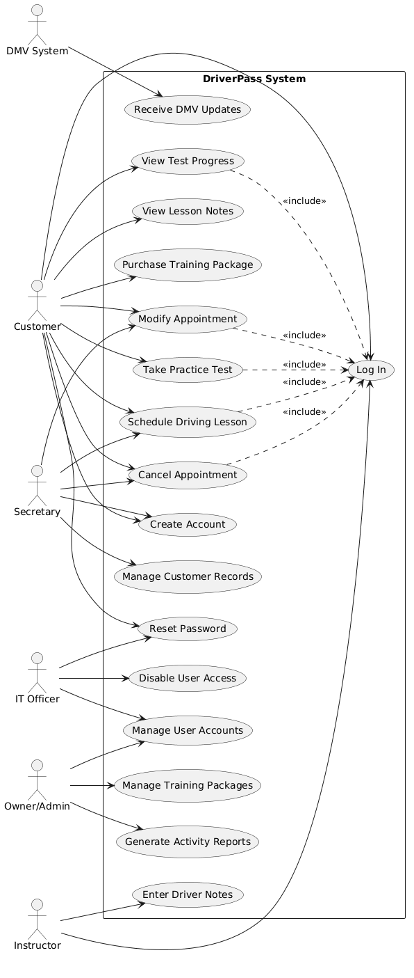

UML Activity Diagrams
Activity Diagram 1: Schedule Driving Lesson
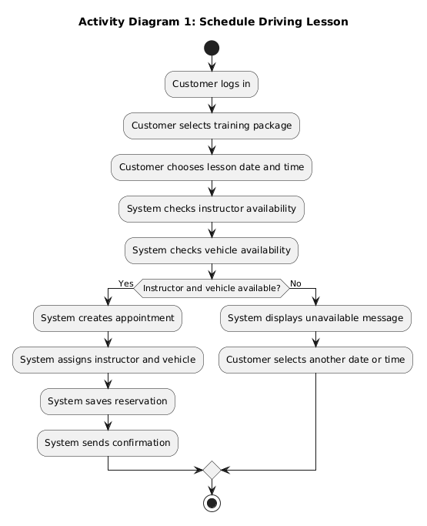
Activity Diagram 2: Take Practice Test
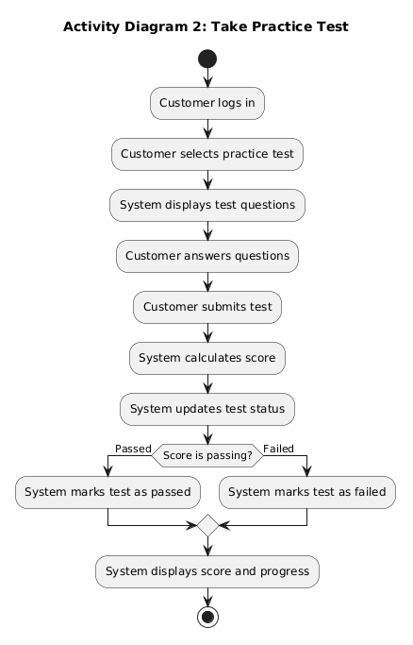

UML Sequence Diagram
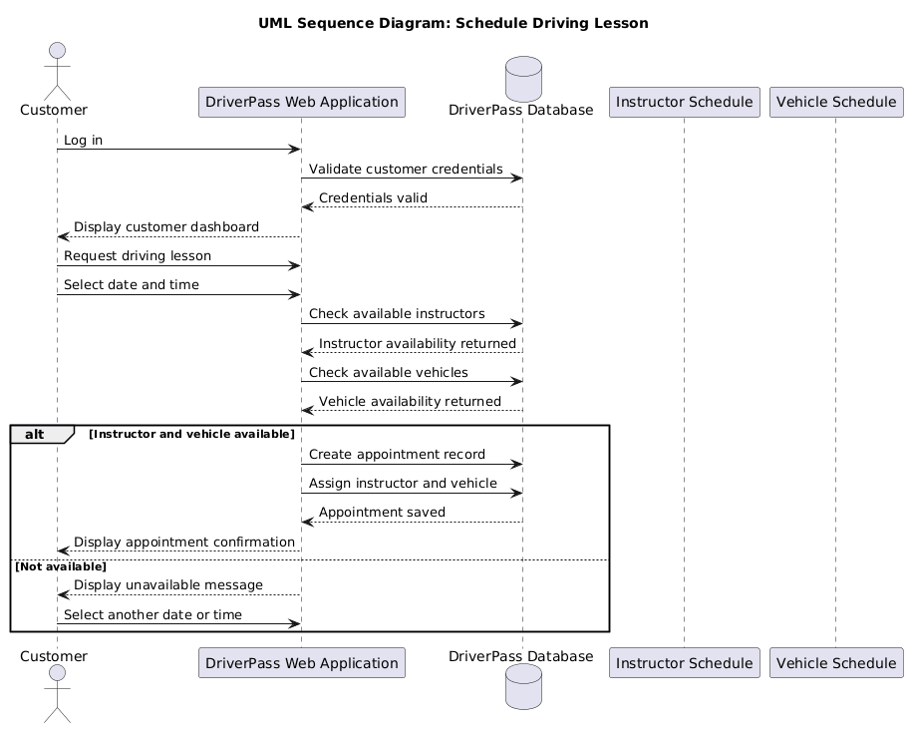

UML Class Diagram

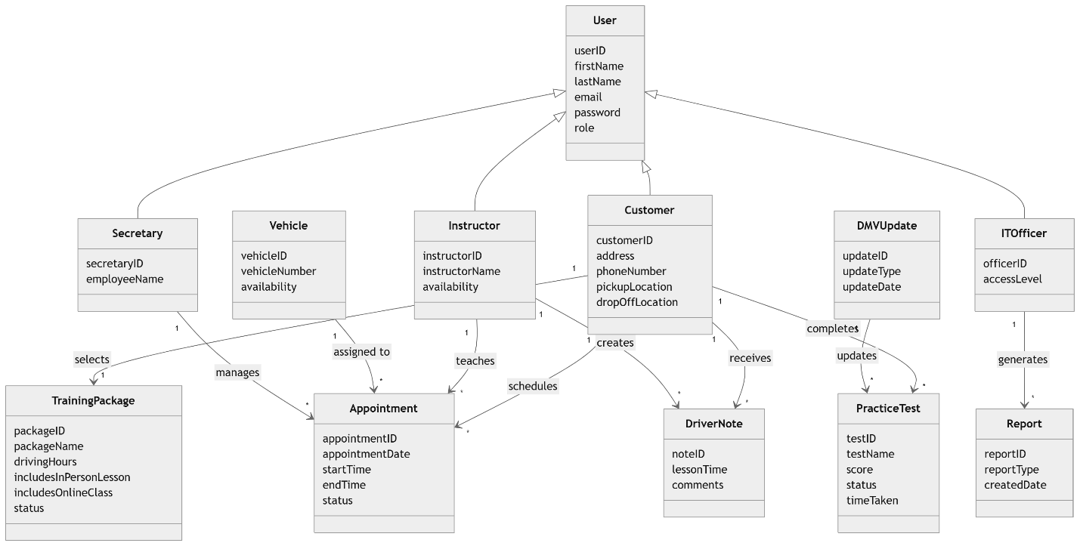

Technical Requirements
The DriverPass system will be a cloud-based web-based application that will be accessible by the customers, secretaries, instructors, administrators and IT staff via a secure web browser. The system shall enable users to register an account, schedule lessons, and make changes to appointments; prepare for practice exams, monitor progress, take driver notes, report, and receive updates on DMV exams.
The hardware needed consists of cloud-based application servers, cloud database servers, employee desktop/laptop computers and customer's computers, tablets and smartphones. All users will need to have reliable Internet access as the system relies on the Internet for scheduling, updates and data synchronization.
The software needed consists of the DriverPass web application, a database management system, web browsers (Chrome, Edge, Firefox, Safari), reporting and security software. Customer information, appointments, instructor schedules, vehicles assigned, training packages, test results, driver notes, and audit logs will be stored within the database.
The infrastructure will include cloud hosting, internet security, automatic backups, disaster recovery, and integration with resources from the DMV for rule and practice-test updates. The system will also need to be HTTPS encrypted, user authenticated, have password reset capabilities, include role-based access control, have account lockout after failed authentication and have activity tracking to support viewing of who created, modified or deleted records.

